CS 5336 - Web Application Development
Project Title: Luggage Handling App
Application Design Document

Class Diagram

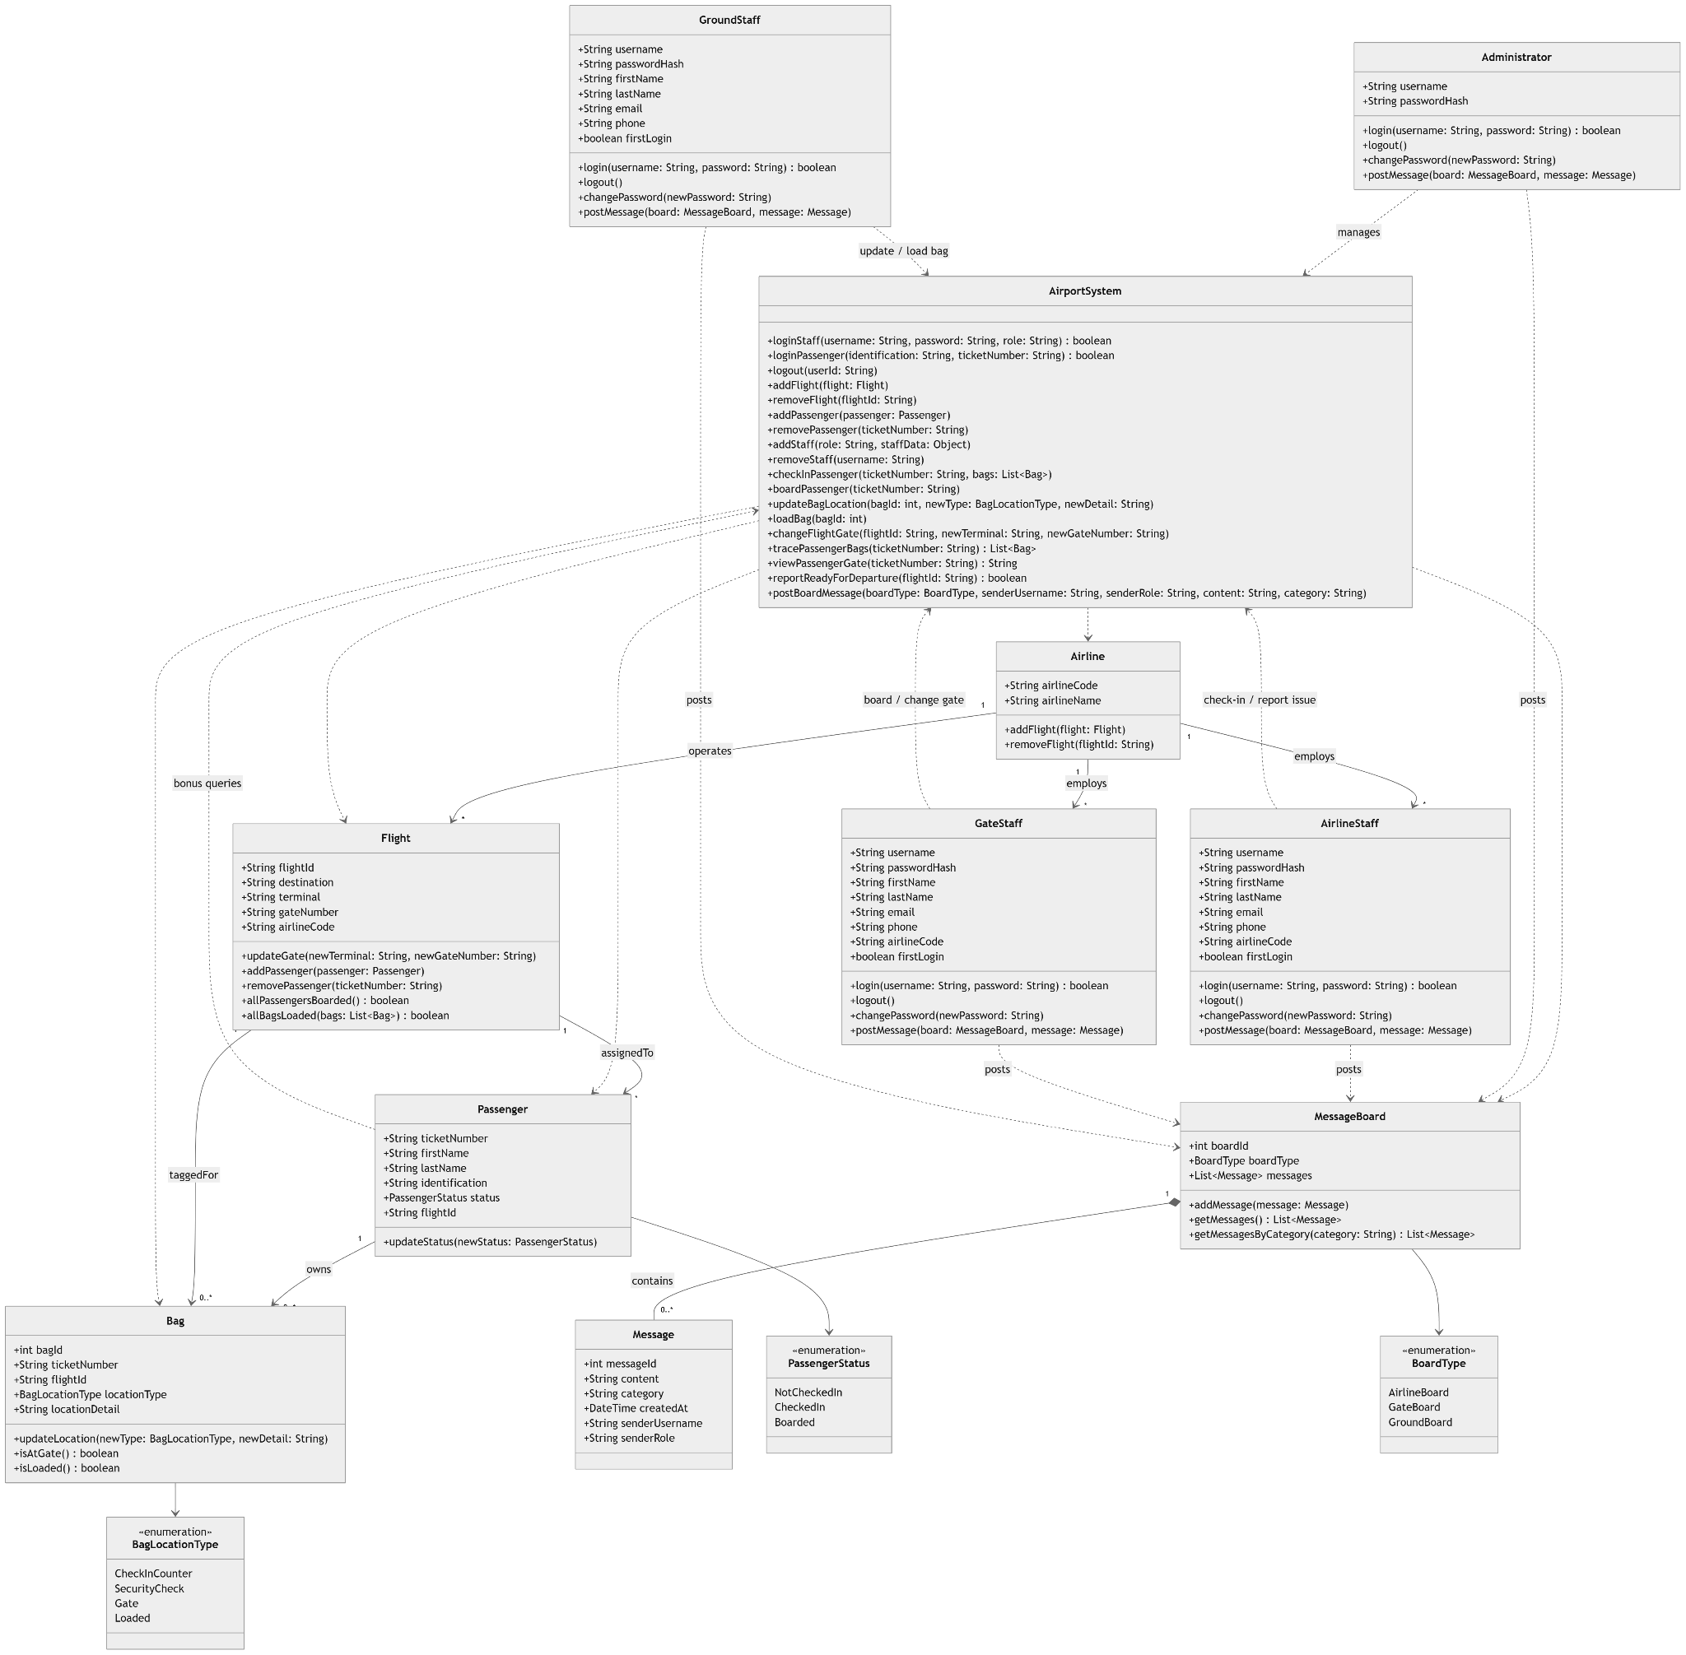

Detailed Description

Common to all classes
All classes have a constructor. All classes will also have getter methods for their attributes. Because all classes contain these functions, they are not included in the method descriptions below.

Classes
Classname: Airport System
Attributes:
Methods:

Classname: Administrator
Attributes:
Methods:

Classname: GroundStaff
Attributes:
Methods:

Classname: GateStaff
Attributes:
Methods:

Classname: AirlineStaff
Attributes:
Methods:

Classname: Flight
Attributes:
Methods:

Classname: Passenger
Attributes:
Methods:

Classname: Bag
Attributes:
Methods:

Classname: MessageBoard
Attributes:
Methods:

Classname: Message
Attributes:
Methods:

